Эффективное использование методики CLIL
при проведении уроков химии

И.О. Исаева
учитель химии
Аршалынская средняя школа №2,
Акмолинская область, п. Аршалы

Метод СLIL (Content and Language Integrated Learning или предметно-языковое интегрированное обучение) в последнее время набирает все большую популярность в преподавании английского языка. Проще говоря, CLIL это изучение на английском (или другом иностранном языке) всех или нескольких предметов школьной программы — это может быть физика, информатика, химия, биология.
Комбинированные уроки существенно повышают у детей и подростков мотивацию к изучению языка. Детям часто бывает трудно понять необходимость изучения английского. Они, конечно, знают, что он пригодится им когда-нибудь в будущем, но зачастую не проявляют никакой активности к изучению как английского языка, так и самой дисциплины. А вот на уроке, где применяются технологии CLIL, язык выступает уже не целью, а средством изучения другого предмета, то есть ученики видят, что с помощью английского можно узнавать новую интересную информацию. Изучение языка сразу становится более осмысленным, ведь он используется для решения конкретных задач здесь и сейчас.
Иначе говоря, CLIL- это взаимное проникновение английского языка и изучаемой науки друг в друга. Методика СLIL является эффективной при соблюдении определенных условий: при проведении разминки необходимо обязательно повторять терминологию на английском языке, при чтении текста ученики должны научиться вычленять ключевые слова из текста, таким образом осознавая основной его смысл. Очень важно использовать различные рисунки, схемы, наглядности для активизации ассоциативной памяти. Существуеют и другие важнейшие правила применения CLIL на уроках естественно-научного цикла. В качестве примера предлагается урок химии с применением методики CLIL:
Subject | Сhemistry
Theme | Chemical elements, their names, symbols. The concept of metals and non-metals
Teacher | Irina Issayeva, Arshaly Secondary School №2
Class | 8
Date | «___»_________201__. |  | Duration: 40 minutes
Location | Аkmola region,  Arshaly settlement |  | Amount | Are present:
 |  |  |  | Are absent:
Lesson objectives | -The pupils know the history of the origin of chemical elements names, their Latin, Russian and English equivalents, designations and pronunciation in formulas.  -The students know that all substances are divided into metals and non-metals.  -Learners give a comparative description of metals and non-metals.
Language objectives | -The pupils use the terminology of previous lessons;  -The pupils know and apply new words and terms;  oxygen, hydrogen, nitrogen, helium, calcium, iron, gold, copper, carbon, phosphorus, sulfur, silicon, metal, non-metal, periodic table, number of element;  -The pupils can read the chemical formulas in English, use chemical symbols .
Expected results on the subject | -All learners will know the history of the origin of the names of chemical elements, that all substances are divided into metals and non-metals. Students give a comparative description of metals and non-metals.  -Most learners will know the Latin, Russian and English names of the proposed 12 elements, the notation and pronunciation in the formulas, using the glossary.  -Some learners will know Latin, Russian and English names and other elements, notation and pronunciation in formulas.
Expected results by language | -All learners will be able to use the terminology of previous lessons using the dictionary  -Most learners will know and apply new words and terms: #Oxygen, hydrogen, nitrogen, helium, calcium, iron, gold, copper, carbon, phosphorus, sulfur, silicon, metal, nonmetal, periodic table, element number#. Students can read the chemical formula in English using chemical signs and symbols using a dictionary.  -Most learners will know and apply new words and terms themselves
Materials | Smart-board, cards with tasks for activity, cards with tasks for text, MM-presentation, watman, markers, scotch, scissors, Periodic tables in Russian, Latin and English languages
Internet-resources: | http://www.vanderkrogt.net/elements/chemical_symbols.php  http://www.ivyroses.com/Chemistry/Chemical-Elements_List.php  http://www.encyclopedia.com/science-and-technology/chemistry/compounds-and-elements/chemical-elements
Procedure
Stages of the lesson |  | Tasks and Exercises |  |  | Notes
1.Introduction  2 minutes  5 minutes  2. The middle of the lesson  3 minutes  10 minutes  5 minutes  10 minutes  The end .  5 minutes |  | 1.Greetings / warm-up:  1. Organization moment . Creating a Collaborative Environment  Hello! Sit down.  First one let’s speak a little.  Please answer the questions:  -What day is it today?  -What is the date today?  -Do you have a notebook? Books?  -Do you have pens?  -Excellent! We study chemistry. Today we will have a very interesting work. But first we will do an activity  2. Activization of previous knowledge of students:  Description of tasks and exercises:  Make a circle, please. You know, there are a lot of terms in chemistry. Now we will work with them. Now we will revise the chemical terms. Let’s count: one, two, one, two ... you should work in pairs. Listen to the task: student one says the chemical term in English, student two in Russian. Then you should change.  Terminology:  safety rules in the chemistry cabinet, tripod, test tube, flask, test tube stand, beaker, spatula, pipette, funnel, evaporation cup substance, chemical properties, physical properties, melting point, boiling point, color, taste, odor, aggregate state, electrical conductivity, heat, magnet action, water, iron, comparative characteristics, pure substances, mixtures, purification of substances, characteristics, contaminated salt, sand, filter, filtration, evaporation, dissolution, precipitation, action, observation, аtom, molecule, simple substances, complex substances, сhemical reaction, compound of atoms, formation of a molecule.  -Excellent! Did you like it? Let’s applaud ourselves for the excellent work!  3. Introduction of new material on the subject content  3.1.Today we have a new theme: Chemical elements, their name, symbols. The concept of metals and non-metals  -What do you think, what will we talk about today? That’s right.  3.2. Definition.  We have important goals for studying chemistry: by the end of the lesson we  - We will know the history of the origin of chemical elements names, their Latin, Russian and English equivalents, notation and pronunciation in formulas.  -we will realize that all substances are divided into metals and non-metals, we will give a comparative description of metals and non-metals.  And we face language goals:  -we will learn to apply new words and terms,  -we will be able to read the chemical formula in English using chemical symbols  3.3.Learning new words and phrases:  Reading strategy 1: Word guessing  You have the text that does not contain keywords.  I give you the task: you should read the text. Emphasize the words that are key to you today. These are the words from the title of the topic or any others. We work independently.  Chemical elements  A chemical element, also called an element, is any substance that cannot be decomposed into simpler substances by ordinary chemical processes. Elements are the fundamental materials that make up all matter.  At present, there are 118 known chemical elements. About 20 percent of them do not exist in nature. They were synthetically prepared in the laboratory. Of the known elements 11 (hydrogen, nitrogen, oxygen, fluorine, chlorine and six noble gases) are gases under ordinary conditions, two (bromine and mercury) are liquids, and the rest are solids.  Elements can be combined with each other. They form compounds. The number of chemical compounds is almost infinite.  When two or more elements are combined to form a connection, they lose their individual identities. The product has new characteristics. They differ from the characteristics of the constituent elements. Gaseous elements of hydrogen and oxygen, for example, can combine to form composite water, which has completely different properties from both oxygen and hydrogen. Water is not an element. We can chemically decompose it into two substances: hydrogen and oxygen. These two substances, however, are elements. They cannot be decomposed into simpler substances.  Now look at our presentation. Compare your answers.  Let's say these words together. Listen and repeat. Open your notebooks. Write down these keywords and their translation  Reading strategy 2: Predicting the content of the text  And now using the keywords, please answer, what are you talking about?  Strategies for developing listening skills,  Strategies for the development of oral speech:  Read the new words and listen to the partner.  Written assignments. Work in group.  So, there are many different chemical elements on our planet. There are 118 of them. I am sure that you already know many of them today.  Listen to me. You should create groups and work in groups. Fill in your table and make a presentation. Look at the table, each element has its serial number, its chemical symbol, the name in Latin, Russian and English. And also the transcription and pronunciation of a chemical symbol in a chemical formula. There is also a place for a clue. Offer your tips to make it easier to remember all the titles.  Use the prompts, please.  Match the pictures with the corresponding elements. Determine which is the element: metal or non-metal, gas or solid  Group №1  Chemical elements  N Chemical symbol Latin name Russian name English name Transcription Pronunciation in the chemical formula Prompts  1 Hydrogenium [ ˈhaɪdrədʒən ] eiʧ  2 Гелий [ ˈhiːlɪəm ] eitʃ i:  7 N [ ˈnaɪtrədʒən ] en  8 Oxygen [ ˈɒksɪdʒən ] ou  Prompts:   a) 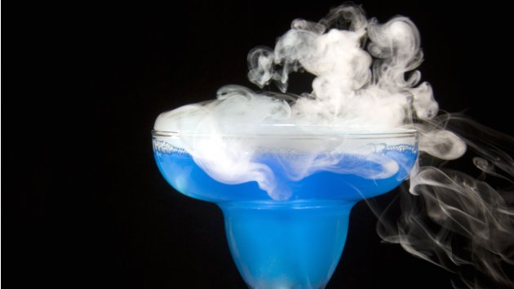 b)  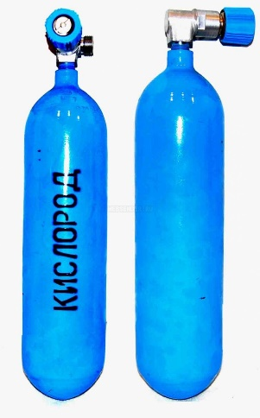 c)  d)  1. H Hydrogenium Водород Hydrogen [ ˈhaɪdrədʒən ]  2. He Helium Гелий Helium [ ˈhiːlɪəm ]  7. N Nitrogenium Азот Nitrogen [ ˈnaɪtrədʒən ]  8. O Oxygenium Кислород Oxygen [ ˈɒksɪdʒən ]  Group №2  Chemical elements  N Chemical symbol Latin name Russian name English name Transcription Pronunciation in the chemical formula Prompts  6 C [ ˈkɑːbən ] si:  14 Silicium [ ˈsɪlɪkən ] si: ai  15 Phosphorus [ ˈfɒsfərəs ] pi:  16 Cера [ ˈsəlfə ] es  Prompts:  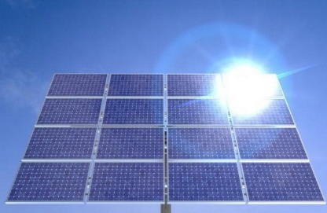 a) 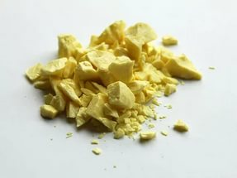b)  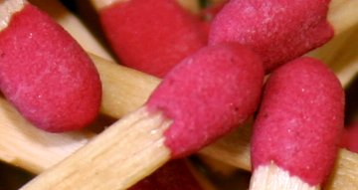 c) 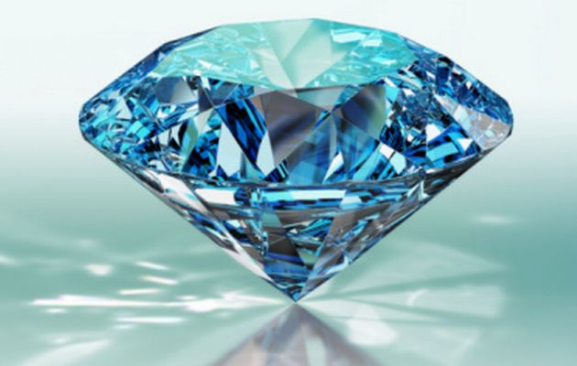d)  6. C Carboneum Углерод Carbon [ ˈkɑːbən ]  4. Si Silicium Кремний Silicon [ ˈsɪlɪkən ]  15. P Phosphorus Фосфор Phosphorus [ ˈfɒsfərəs ]  16. S Sulfur Сера Sulfur [ ˈsəlfə ]  Group 3.  Chemical elements  N Chemical symbol Latin name Russian name English name Transcription Pronunciation in the chemical formula Prompts  20 Calcium [ ˈkælsɪəm ] si:  26 Fe [ ˈaɪən ] ef  29 Медь [ ˈkɒpə ] si:ju:  79 Gold [ ɡəʊld ] ei ju:  Prompts:  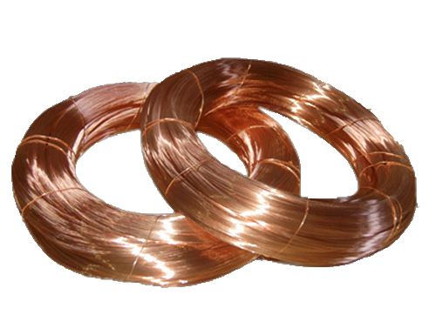 a) b)  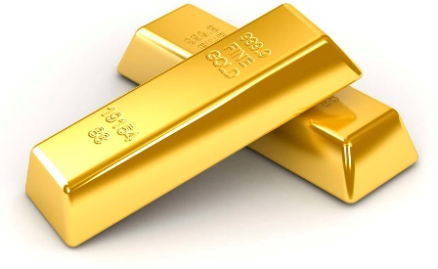 c) 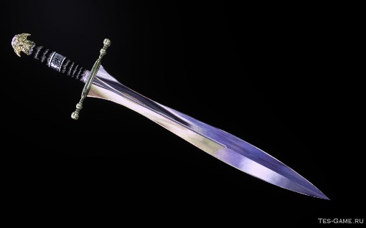d)  20. Ca Calcium Кальций Calcium [ ˈkælsɪəm ]  26. Fe Ferrum Железо Iron [ ˈaɪən ]  29. Cu Cuprum Медь Copper[ ˈkɒpə ]  79. Au Aurum Золото Gold [ ɡəʊld ]  - And now let's revise the names of chemical elements together.  Listen and repeat.  Can you suggest any other elements? Excellent! We will study them gradually.  At this moment answer my question: do you think which of these elements are metals, which nonmetals are gases. What nonmetals are solids. What are the properties of metals or non-metals? Excellent!  So, today you learned a lot of new things.  Follow up/The homework:  Write down your homework: learn new words and terms in English. Learn the paragraph "Chemical elements"  Feedback: please fill in the table:  Today at the lesson  1 I liked / did not like the activity, because:  2 The topic was difficult / easy, because ...  3 I understood / did not understand the meaning of the text  4 I understood / did not understand how the English names of the symbols of chemical elements are read  5 The easiest thing for me today was ...  6 The most difficult for me today was ...  7 I can evaluate my work in the class as excellent, good, average, bad, because ...  Note: If you want, you can fill out the same card in Russian. |  |  | Students respond to teacher questions  Students work in a general circle in pairs, ask each other questions on the terminology studied earlier  Students independently try to understand the topic of the lesson, understand the objectives of the lesson, the teacher helps  Students read the text themselves, find the keywords  Students compare the work performed with the text on the mm presentation Correct the mistakes.  Repeat the pronunciation of these words after the teacher.  Writing words and their translation into a notebook  Pupils read words in pairs to each other  Students work in groups, fill in the table, present their works, students repeat all the names of chemical elements  Pupils together read and repeat the names of chemical elements, their pronunciation and transcription  Students answer the questions.  Students complete the table, hand them in to the teacher

Используемый Интернет- ресурс: http://proenglish-blog.ru/metody-i-metodiki/chto-takoe-clil-ili-poznaem-mir-cherez-anglijskij.html

